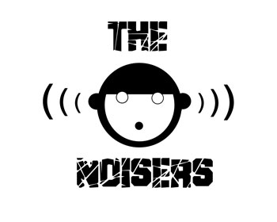
The Noisers: “Why not louder?”

If we say that THE NOISERS come making noise, we fall into the easy joke, but the truth is that this quartet from Pontevedra (NW Spain), really thunderous sound. Its powerful sound drinks from Red Hot Chilli Peppers, Foo Fighters, Nirvana, Ramones, Sex Pistols, Pearl Jam, Oasis and even AC / DC, but without any of them look like .... already the title of his album "Why not louder?"
You listen and imagine as the soundtrack in a scene full of tension in a David Lynch movie or while Susan Sarandon and Geena Davis fleeing police in Thelma & Louise.
Mostly guitar and voice (oh man!, ... what a voice!) From Hugo, combined with a powerful rhythmic base and some vocal arrangements rare in such young musicians, creating a climate difficult to classify but little that you like rock and roll, you get into the depths of your head and you will be surprised singing songs like "Feel in Rock & Roll."
Javi (bass), Hugo (vocals, guitar), Roxo (drums) and Ivan (guitar) are THE NOISERS, a very young band with a history yet to be written, is that in his short life, have not yet touched off Galicia, of course that may have changed when you read this.
The Noisers, a band from “YouTube” generation
THE NOISERS are an example of the “YouTube” generation , they decided to start playing after spending hours and hours watching online videos of their favorite bands .... and debuted without a bassist!
Flor y Nata Records has set on them and released their debut, an EP-CD entitled "Why not louder?" Which stresses "Feel in rock & roll," the first single and video that have made up to any band international band with years of experience.

But the disc does not stop there, do not miss "I am falling," "Iguana Rock", "Before You" ...
promo@florynatarecords.com  www.florynatarecords.com | 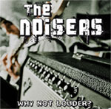 | thenoisers@hotmail.com  www.myspace.com/thenoisersband
FyN-44 – 8435015511319 - EP – www.discmedi.com – PVP (recomended) 5 €

