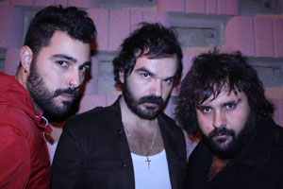
SONIDO BIKINI.... FOR THE COMPLETE YEAR

SONIDO BIKINI is a name that might suggest, beach, sun, summer and facile meat ringtone songs, however it is a powerful and raw noise-pop band formed in Móstoles (Madrid), filmed in the Madrid stages now give the leap presenting their first album "LA CASA DE ERNESTO."

ONLY 3, BUT THEY MAKE NOISE

SONIDO BIKINI are just a trio: Isaac: guitar and vocals, Paco bass and vocals, and drummer Mario, each with disparate influences and Isaac came from the world of classical and flamenco guitar, not having touched an electric sound to reach Sonido Bikini, Paco eats britpop and is the composer of all the songs and Mario have punk influences marked.

And among the three manage to provide to SONIDO BIKINI a sound next to the garage, blunt, sharp guitars and rolling grounds that create a natural atmosphere. SONIDO BIKINI boast of their noise-pop with no additives, no effects, no pedals, no studio tricks ... with only a Rickenbacker guitar.
In his particular sound is difficult to find parallels, but as starting points could put Oasis and Los Planetas.
SONIDO BIKINI been shot making repertoire local successes were semifinalists in the Sala Imperio Contest Pop, and third in the 2nd La Siesta Music Concept Festival in Madrid.

EVERYTHING STARTED ON “LA CASA DE ERNESTO” (Ernesto’s house)

The SONIDO BIKINI’s debut album is a five-song EP concentrate, generic entitled "LA CASA DE ERNESTO", not because you call one of the songs, but because practically everything has been done there. And is that Ernesto is the owner of the recording studio, the premises of Alcorcón City where tested and where they have emerged a unique sound and songs that speak of love implied, of death, vices ...

"PONLE UN PRECIO" is the first song EP that serves as an introduction, a song that starts with an explosion of vitality and continuity with a letter challenging, is one of those songs that when large groups are still hungry. What's more, when you know "Míranos", do not head sucrase, and the album continues with other lashes as "En el fin del mundo", "Cambio por momentos" or "Sol Gris". Nobody can ever say
LA CASA DE ERNESTO is a "Two pieces" record....
now we know how sounds a bikini and we like!

promo@florynatarecords.com  www.florynatarecords.com | 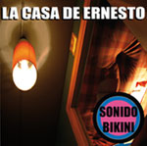 | sonidobikini@hotmail.es  www.facebook.com/pages/SONIDO-BIKINI/135669099784103  www.myspace.com/sonidobikini

FyN-57 EP – PVP (recomended): 5 € – 8435015512644 – Records stores distribution: www.discmedi.com

