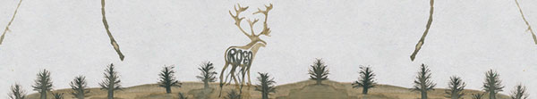

ROCCO bring us XXI century rock-folk

Soon you are well informed about the spanish indie scene, you've heard or read about ROCCO, a quartet from Dénia (Alicante) that focuses on sounds near-folk rock that occurs in the mountain states of the United States and Canada and its obtained a more excellent reviews with his first recording.

You may even be one of the privileged owners of one of the few copies of the first self publishing limited edition of the CD.

These early copies have had a presence at key points in the independent scene as prestigious as the "39 Sonidos" at Onda Uno, "Toxicosmos" at UPV Radio, "La Isla de Encanta" at Radio Circulo, "Delicatessen" at iCat FM, Scanner FM, "Islas de Robinson" at Radio 3 or even a top number 1 in the Mondo Sonoro Valencia Magazine.

In Flor y Nata Records could not let an album like this to remain a delicacy only for a small elite of electeds. The world had to know (and for that we have with you) and here are our issue with respect to 100% content such as ROCCO wanted to reach its audience from the first time.

Rarely a debut album has been so lauded

ROCCO arise in Dénia (Alicante) in the summer of 2009, initially to participate in the Festival Flexi Verbal Dénia, although the experience was so positive that a few months already had a repertoire of his own songs and a good list concert. This is how two components from Astronaut: Eduardo Guzman (guitar and vocals) and Rafa Peiró (bass), plus two from Gomoso: Javi Martinez (guitar and vocals) and Jaime Puig (drums) have shaped one of the groups more projection of the current indie scene.

Folk + pop + rock + soft voices = crist & fresh songs

His music blends nicely with folk and pop rock elements and results in a crisp, cool songs. A soft voices accompanied by a manicured instrumentation flow through some songs sung in English, and influenced, as discussed by CSN & Y, Simon & Garfunkel, Elliott Smith, Wilco, Calexico, Fleet Foxes, Deerhunter & Sufjan Stevens and others.

The album, which is called as the band is a breath of fresh air, an album to listen to (if possible) outdoors, feeling the wind in your face driving a convertible or on a sun lounger on the terrace, evoking, as the song, snowy mountains or a endless wheat fields.

There are twelve songs recorded in Atomic studies in Denia produced by Rocco and Mark Dasousa who helped the band in keyboards, Andrea De Pascual (vocals) and Javi Torres (viola), of which it is difficult to highlight any ... "The Wind (that blows here)," "On my belly", "Elliott", "Every light here," "Sooner or later," all have something that makes them special.

promo@florynatarecords.com  www.florynatarecords.com | 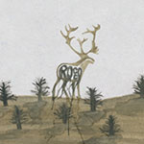 | rocco@hotmail.es  www.myspace.com/roccotheband  www.roccotheband.com

FyN-56 – PVP (recomended): 11 € – 8435015512637 – Records stores distribution: www.discmedi.com

