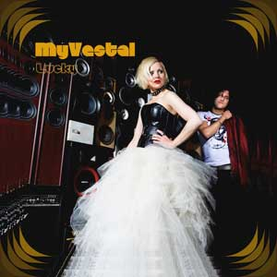

MY VESTAL: “Electro-Vintage”

It was on February 2009 when in Oviedo (Asturias, North Spain) agreed Marcos Perez, a Moog keyboards, Hammond organ and Fender guitars fan with experience in several garage bands, with Eva Fernandez, the owner of a personal voice that given before to Susan 6 and Esmussein. Together they started the project MY VESTAL.

A project based on the fusion of pop, rock and electronic themselves labeled as ELECTROVINTAGE a personal sound and recognizable dotted with many influences, both musical: Goldfrapp, Suede, Muse, PJ Harvey, and literary: Tom Spanbauer, William Blake, or movie: Veronica Lake.
There have even been those who have found points of connection between Eva Fernandez and Bjork.

Pop, Rock & electronic

MY VESTAL soon proclaimed winners from 12th Oviedo Rock City Contest, received four nominations at the Asturias Music Awards and self-produce their first album "My Vestal" which was followed by a lot of concerts. "We never use pre-recorded basis, but are scheduled" qualifies in this respect the musician. "They are thrown from a sequencer that controls the keyboards, so every sound can be modified and modular transform at any time, so our sound in live."

“Never say never” the preview fron the CD “Lucky”

Flor y Nata Records noticed them around summer and have the result, an album called "Lucky" in which MY VESTAL will choose to promote its most rock and electro. "In our songs we try to inner feelings, human emotions, emotional states ... It is a music of contrasts Sometimes an idea is sad but it is said in a contrast musically, and vice versa. This translates into a game of emotions sought by you inside and makes you think how you feel. "

The advancement of "Lucky" is "NEVER SAY NEVER", a show that perfectly sums up the electro-vintage sound that is created by merging the unique melodies of vocalist Eva Fernandez, guitar sounds and synths, by Marcos Perez.

www.florynatarecords.com  info@florynatarecords.com |  | https://www.facebook.com/myvestal  myvestal@gmail.com
www.myvestal.bandcamp.com
FyN-65 – PVP (recomended) epcd physical: 5 € / digital: 2 € – 8435015513320 – records stores distribution: www.discmedi.com

