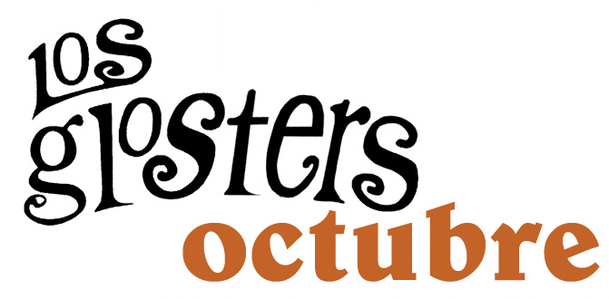

The most mod+ye yé quintet from the former Roman Empire more publishes its second cd with the just burned again Flor y Nata Records. Again is a EPÉ with four own songs and one version under the generic title of OCTUBRE.
SHA LA LA, FIN DE SEMANA is the hit single of this new disc, a song that narrates the count down towards a wished weekend in which duties are left back and in that finally of can do everything they want, in this case something as simple as to have in fun.

This song videoclip exists and it’s enclosed also in the EPÉ, directed by Josep Sentis from Sengar TV. In the video LOS GLOSTERS show us some typical corners of their city, Tarragona.

The disc is completed with EL MALO with the collaboration of Miqui Puig (former lead voice of Los Sencillos), the the one that gives to title to the CD OCTUBRE, SIN TI, with another guest of luxury: Gaby Alegret, the charismatic voice of Los Salvajes and LA IRRESPONSABLE (Le Responsable), an cover of a 1969 french classic who have sung from Brigitte Bardot to more recently Vanessa Paradis.

LOS GLOSTERS are: Evan Dedes (drums), Puri Pedrola (bass), Héctor Mir (keyboards and voices), Ramón Cuenca (lead and voice) & Carlos García (guitars & voices).

With this new disc, LOS GLOSTERS will initiate a tour that will extend until end of the summer of 2006 in which also they will sing MIRAME, a song only enclosed at the compilation SONIDOS DE LA COSTA ESTE of recent appearance that already has become one of the most looked for by the collectors of its songs. . Los Glosters discographt at Flor y Nata Records completes with its previous epé titled ESCUCHA! issued in 2005 where they emphasized songs like JUEGO A TRES and the one that gives title to the disc.

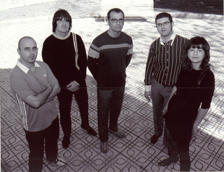

Ask for your EPÉ at www.florynatarecords.com or at www.losglosters.com

 | 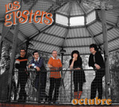 | 
info@florynatarecords.com  www.florynatarecords.com |  | info@losglosters.com  www.losglosters.com
FyN 16 – PVP aconsejado: 6 Euros - 8435015508531

