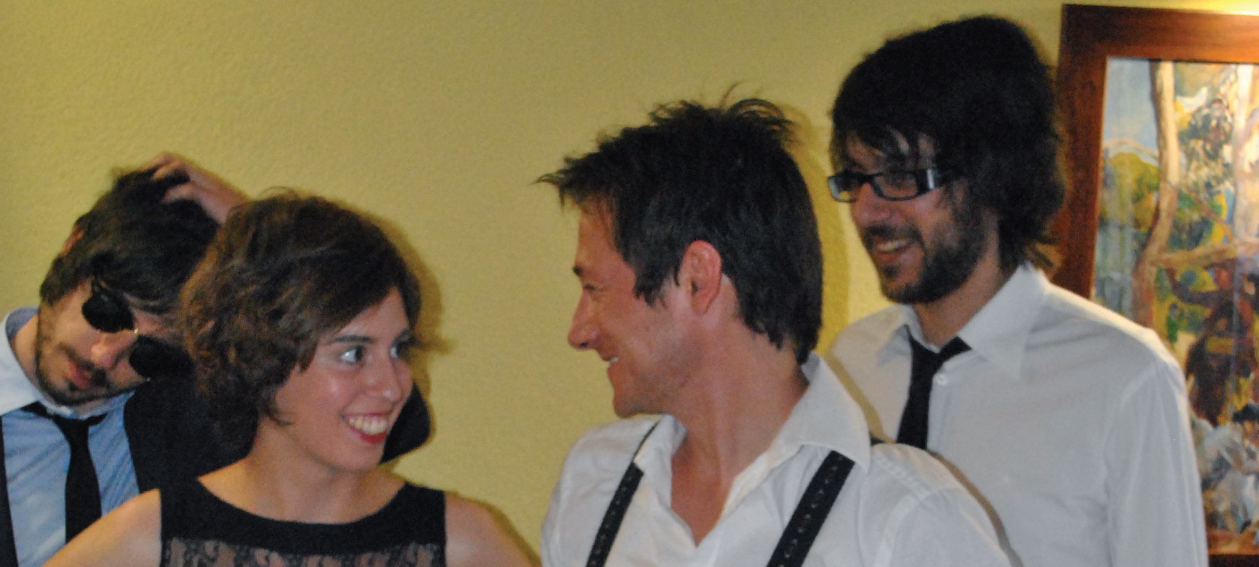Copo
“Vals sobre un escarabajo”

A LITTLE BIT OF HISTORY

I must confess I do not know if I would have given the same attention if instead of a demo perfectly finished, they had given me a sad CD with the name COPO written in permanent marker on the cover. The year was 2008 when Jaume gave me the Waimea Pub, the first record of the COPO named "Laberintos de hielo"-my copy is numbered 005 -. I began to listen with one touch of white cardboard cut out and I said, something made ​​with much love and a craft so can not leave something banal.

Listening to him at home, I found a crude product, perhaps a little harsh to the taste, where compositions that seemed as bright, trying to sound density and texture deliberately awkward catch the listener and lead him through the four songs disk and not just over them. One in particular caught my attention, which eventually included in the disk "Recopilación CAC 2008. Esto es Valencia, ¿acaso no lo eres tu? "(Saimel Editions, 2008): "Buzos y Sirenas"

In late 2008, COPO goes back into the studio to check what will be their second demo "Matrioshka". It is the sixth of songs that are recorded, among which are classics in their repertoire as "Mil Colores" or "Meteorica # 1", though, deserves special mention the opening track on the disc, the immeasurable, "La V Guerra Mundial". This issue, where the group reaches one of its peaks compositional, already has the seal COPO, sound and development are proper and exclusive to the band. Added to the above one more than exquisite and dazzling presentation folder for the model in which the manufacturing returns to make each copy an object of desire, making each and every one of the copies of this disc collector's jewelry.

Then came "Juegos de Invierno", third in the race of the Canals. With a delicate, very carefully defined and artwork (http://ilustrakatiuska.blogspot.com/), recorded and mixed in January 2011, sees the light after several failed attempts and wisely discarded with the sole intention of illuminating a job well and the fact that the band felt completely satisfied. The result is a total of seven songs cleverly arranged, with which COPO sign exultant disc, dense, yet optimistic, and which already peep new paths and intentions, without leaving the main lines of those already moved.

After "Juegos de Invierno", Rocío joins COPO replacing Jaume Parraga and the band decided to address certain outstanding tasks with renewed spirit. With a mini-concert (November 2011) in Valencia venue DELUXE room as a presentation of the "Juegos de Invierno", they give the entry a CD-single with one song: “Tiroteo en las Bahamas" in limited edition completely handmade. Almost immediately get into the studio to put in the hands of Carlos Soler Otte new material from the band that takes the form 4 new themes that are the ones you have at hand.

VALS SOBRE UN ESCARABAJO

Recorded in February 2012 in Blackout by Carlos Soler Otte (who also takes care of the
mixture) and mastered by Mario G. Alberini at Kadiforniastudio in April 2012 the four new
Songs come under one of the hallmarks of more extensive (and reputable) state trajectory: Flor y Nata Records. Four issues of enormous vitality that reflect the exact moment in which is the group. "Todos los santos" and "La Gran Novedad Mundial" are two great songs that fascinate the first listen to the other two do not need more. Complex sound density frames that explode in choruses Light as "La Gran Novedad Mundial" (possibly the best of all COPO have made). Surprising is the apotheosis, period epic “El Rey" that opens the album, with its coral development and rhythmic forcefulness on ordering. "Dias de Feria", an example of compositional maturity, sweet and nostalgic and reminiscent of the days ... Without relinquishing the COPO sound already coined brought from previous
work with this release have managed to maintain their attachment to the noisiness truce and who know how to deal with equal mastery over the 4 minutes (on average) during the songs. No room for excesses, not on this EP. But everything will come.
Illustration and design re-run by Cristina Ferrer (http://ilustrakatiuska.blogspot.com), on a disk named with a pun, a kind of acronym that I will not reveal here but which few escape.

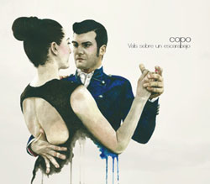By: Javier Pérez Montes [Host & director of the radio show “El Club de Amigos del Crimen” in
Radio Klara 104.4 FM Valencia]
copobajoelsol@gmail.com / copovals.bandcamp.com / www.myspace.com/copomusica

Management: www.hurrahmusica.com | www.florynatarecords.com

