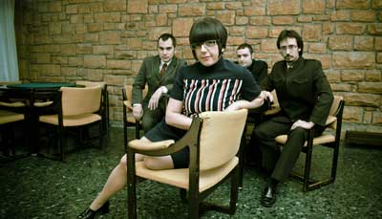
BRAND NEW SINCLAIRS, black soul & ye-yé insolence

Forceful rhythmic base, crunchy guitars played with taste and very classy, elegant and sweet voice of Ana Sinclair, the band shape of black soul and ye-ye insolence, as they themselves like to be defined.

This is one of the best definitions found in the net of BRAND NEW SINCLAIRS, the latest addition to Flor y Nata Records, the oldest of the spanish indie labels (1981-2011).

Many already know them by their previous album "Ten Blue Pills" (Bip Bip Records 2009) with which the Barakaldo’s quartet debuted. If even then managed to attract attention and demonstrate that theirs is a blend of garage, R & B, soul, ye-yé and beat explosion, with this second album "Healing Souls" released on CD, digitally and in luxurious and nostalgic vinyl, you definitely conquer.

BRAND NEW SINCLAIRS is that even being a band today, not only neglected, but used those elements that gave groups of 60’s distinctive and unique sound that now reinvented and fused with pop melodies that fits perfectly with Ana’s voice, achieving a mark of identity and a unique sound.

BRAND NEW SINCLAIRS are: Ana Sinclair voice & percusions; Andi Sinclair guitar & voices; Julio Sinclair bass & voices; & Rafa Sinclair drums.

“Healing Souls”.... already a “Greatest Hits”

After a brief introduction, "Healing Souls" opens with "Heal my soul", a dance shot makes you connect with the sound of Brand New Sinclairs for not leaving until the last note of the disc, with a chorus that you will be recorded head: "Oh my sweet doctor, I need my medicine, I want to heal my soul" and, like good movies, starting with an earthquake and still rising, in this case the rise are songs like "Ronnie", "A Way of Life" or "Where you real?", all with their own life but that also seem to be made to take that and no other place on an album that could well be a "Greatest Hits" by Brand New Sinclairs, and if not While.

HEALING SOULS was recorded and mixed by Hans Kruger (Montreal Studios de Navarra - november 2010) and masterized by Ibon Larruzea (Studios Euridia)

promo@florynatarecords.com | 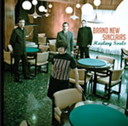 | brandnewsinclairs@gmail.com
www.florynatarecords.com |  | www.myspace.com/brandnewsinclairs
FyN-51 CD 8435015512200 PVP: 11 € – FyN-52 LP 8435015512217 PVP: 15 € – records stores distribution: Discmedi
photos: www.photofreelance.es

